FULL STACK DEVELOPMENT WITH MERN PROJECT DOCUMENTATION

# Introduction

Project Title : ShopSmart : Your Digital Grocery Store Experience

Team id :   LTVIP2025TMID54978

Team Members:

# Team Leader:

GURUNADHAM GUTTA– Full Stack Developer & Project Coordinator

Responsible for overall planning, coordination, GitHub management, and integration of frontend and backend.

# Team Member:

GUJJULA NITHIN REDDY– Frontend Developer

Works on the React-based UI, handles component design, page routing, and user interactions.

# Team Member:

GUMMADI CHETANA– Backend Developer

Builds RESTful APIs using Node.js and Express.js, manages authentication and server logic.

# Team Member:

GUMMADI CHANDANA– Database Administrator

Designs and manages MongoDB schemas, handles CRUD operations and ensures data consistency.

# Project Overview

* + **Purpose:**

The purpose of **ShopSmart** is to digitize the traditional grocery shopping process by providing a seamless, fast, and reliable online platform. It aims to:

* + Enable users to shop for groceries anytime, anywhere.
  + Minimize physical store visits and long queues.
  + Connect customers with local grocery vendors.
  + Offer a personalized and user-friendly shopping experience.
  + Support vendors in managing inventory and increasing sales digitally.
  + ​

# Features

**👤 User Features**

* + Easy Registration & Login
  + Browse Products by Category & Brand
  + Add to Cart & Wishlist
  + Apply Promo Codes & Discounts
  + Secure Payments (UPI, Card, Wallet)
  + Live Order Tracking
  + View Order History & Reorder

# 🛍️ Vendor/Admin Features

* + Add/Edit/Delete Products
  + Manage Stock & Pricing
  + View Orders & Sales Reports
  + Control Product Availability
  + Manage User Queries

# 📱 Other Key Features

* + Responsive Design (Web & Mobile)
  + Smart Search & Filters
  + Personalized Product Recommendations
  + Role-Based Access (User, Vendor, Admin)
  + Notifications via Email/SMS

# Architecture

**System Architecture Diagram**

**+** **+**

# | User Interface |

**| (React.js / Mobile) |**

**+-----------+** **+**

# | v

**+** **+**

# | Backend API Layer |

**| (Node.js + Express) |**

**+-----------+** **+**

# | v

**+** **+**

# | Authentication |

**| (JWT / Middleware) |**

**+-----------+** **+**

# | v

**+** **+**

# | Database |

**| (MongoDB) |**

**+** **+**

# Components

1. **Frontend (React.js)**
   * Handles UI/UX for customers, vendors, and admins
   * Interacts with backend via REST APIs
   * Responsive design for web and mobile

# Backend (Node.js + Express)

* + REST API layer for handling user requests
  + Routes for user, product, cart, order, and admin operations
  + JWT-based authentication and authorization

# Database (MongoDB)

* + Stores users, products, carts, orders, and vendor data
  + Enables flexible schema and fast querying

# Authentication

* + Secures user sessions using JWT
  + Role-based access: user, vendor, admin

# External Services (Optional)

* + Payment Gateway (e.g., Razorpay/Stripe)
  + Email/SMS Notification APIs
  + Cloud Storage for product images (e.g., Cloudinary)

# Setup Instructions Prerequisites

* + Node.js >= 18
  + MongoDB installed and running (local or cloud - MongoDB Atlas)
  + npm or yarn

# Installation

git clone https://github.com/your-username/ShopSmart.git cd ShopSmart

cd server npm install cd ../client npm install

# Environment Variables

Create a .env file in the /server folder with the following content: PORT=3000

MONGO_URI=mongodb+srv://yourusername:<db_password>@cluster0.mongodb.n

et/shopsmart?retryWrites=true&w=majority&appName=Cluster0 JWT_SECRET=your_jwt_secret

🔐 Replace <db_password> with your actual MongoDB password.

✅ Make sure your IP is whitelisted in MongoDB Atlas or use 0.0.0.0/0 for open access (development only).

# Running the Application

1. **Start the backend server:**

cd server npm start

**Runs at** [**http://localhost:3000**](http://localhost:5000/)

# Start the frontend:

cd ../client npm run dev

Runs at [http://localhost:3](http://localhost:5173/)000

# Folder Structure

ShopSmart/

│

├── client/ # Frontend (React.js)

│ ├── public/ # Static files

|  |  |  |
| --- | --- | --- |
| │ | └── src/ | |
| │ | ├── assets/ | # Images, icons |
| │ | ├── components/ | # Reusable UI components |
| │ | ├── pages/ | # Route-based page components |
| │ | ├── context/ | # React context (e.g., Auth, Cart) |
| │ | ├── services/ | # API calls |

│ ├── App.jsx # Main app component

│ └── main.jsx # React DOM entry point

│

├── server/ # Backend (Node.js + Express)

│ ├── config/ # DB connection, JWT config

│ ├── controllers/ # Request handlers

│ ├── models/ # Mongoose models (User, Product, Order)

│ ├── routes/ # API route files

│ ├── middleware/ # Auth, error handling

│ ├── utils/ # Helper functions

│ ├── .env # Environment variables

│ └── server.js # Entry point for backend

│

├── .gitignore # Files/folders to ignore in Git

├── README.md # Project documentation

└── package.json # Root config (optional if monorepo)5.Running the

# Application Frontend:

* cd client
* npm start

# Backend:

* cd server
* npm start

1. **API Documentation**

**🔐 Authentication & Users**

|  |  |  |  |
| --- | --- | --- | --- |
| **Method** | **Endpoint** | **Description** | **Access** |
| **POST** | **/api/auth/register** | **Register a new user** | **Public** |
| **POST** | **/api/auth/login** | **Login and receive JWT token** | **Public** |

|  |  |  |  |
| --- | --- | --- | --- |
| **GET** | **/api/users/me** | **Get current user info** | **Private** |

**🛒 Products**

|  |  |  |  |
| --- | --- | --- | --- |
| **Method** | **Endpoint** | **Description** | **Access** |
| **GET** | **/api/products** | **Get all products** | **Public** |
| **GET** | **/api/products/:id** | **Get product by ID** | **Public** |
| **POST** | **/api/products** | **Create new product** | **Admin/Vendor** |
| **PUT** | **/api/products/:id** | **Update product details** | **Admin/Vendor** |
| **DELETE** | **/api/products/:id** | **Delete a product** | **Admin/Vendor** |

**□ Cart**

|  |  |  |  |
| --- | --- | --- | --- |
| **Method** | **Endpoint** | **Description** | **Access** |
| **GET** | **/api/cart** | **Get user cart** | **Private** |
| **POST** | **/api/cart** | **Add item to cart** | **Private** |
| **PUT** | **/api/cart/:id** | **Update item quantity** | **Private** |
| **DELETE** | **/api/cart/:id** | **Remove item from cart** | **Private** |

**📦 Orders**

|  |  |  |  |
| --- | --- | --- | --- |
| **Method** | **Endpoint** | **Description** | **Access** |
| **POST** | **/api/orders** | **Place a new order** | **Private** |
| **GET** | **/api/orders** | **Get current user’s orders** | **Private** |
| **GET** | **/api/orders/all** | **Get all orders (admin only)** | **Admin** |
| **PUT** | **/api/orders/:id** | **Update order status (e.g. shipped, delivered)** | **Admin** |

 **Admin/Vendor Management**

|  |  |  |  |
| --- | --- | --- | --- |
| **Method** | **Endpoint** | **Description** | **Access** |
| **GET** | **/api/users** | **Get all users** | **Admin** |

|  |  |  |  |
| --- | --- | --- | --- |
| **DELETE** | **/api/users/:id** | **Delete a user** | **Admin** |
| **GET** | **/api/dashboard/stats** | **Get overall statistics** | **Admin** |

1. **Authentication**
   1. User Registers/Login
   2. Server verifies credentials
   3. If valid, server returns a JWT token
   4. Token is stored in client (localStorage/cookies)
   5. Protected routes require the token in headers

# User Interface

Home Page with Product search

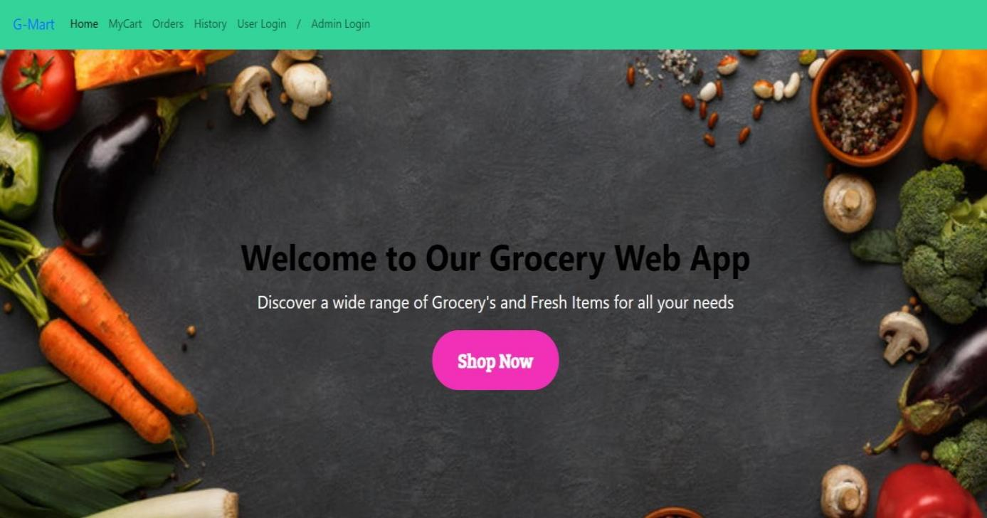

Login form

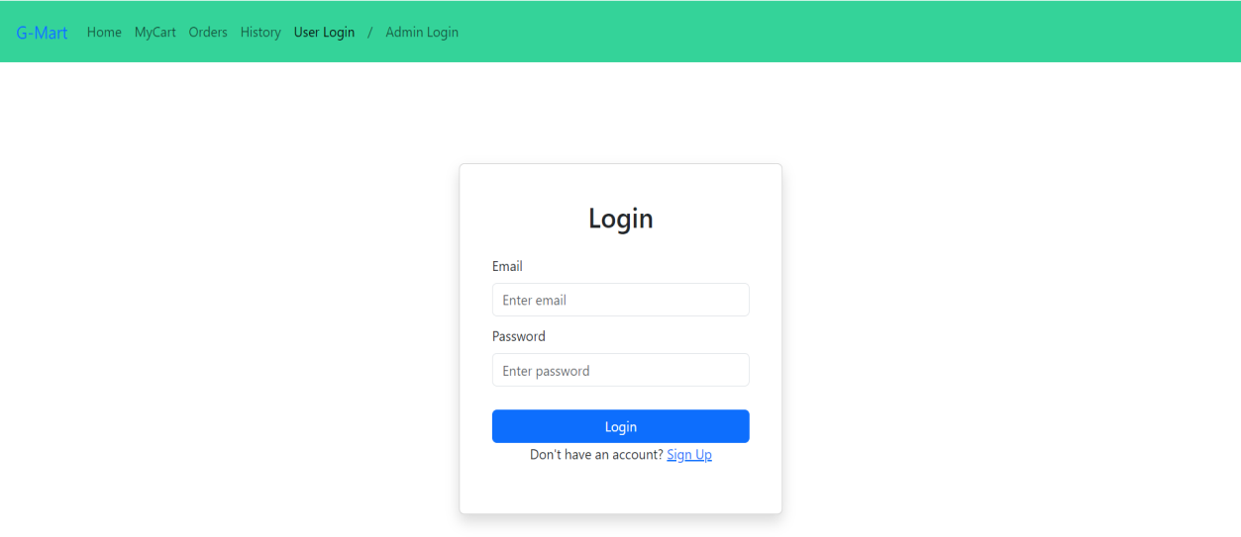

Items Page:

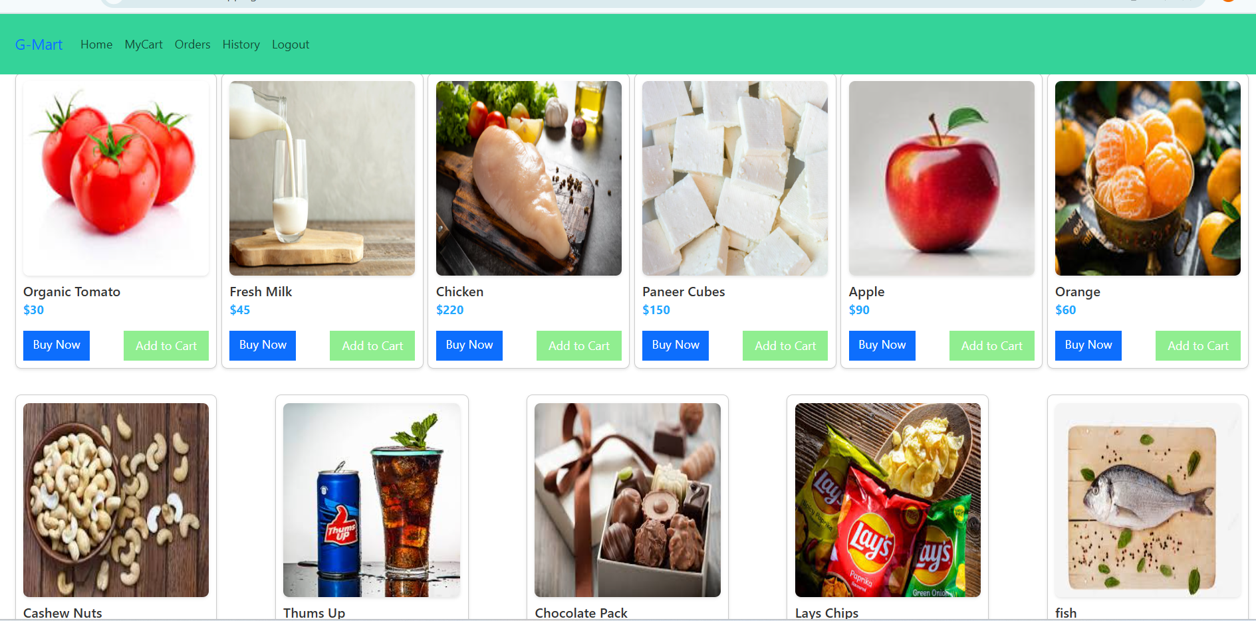

My Cart:

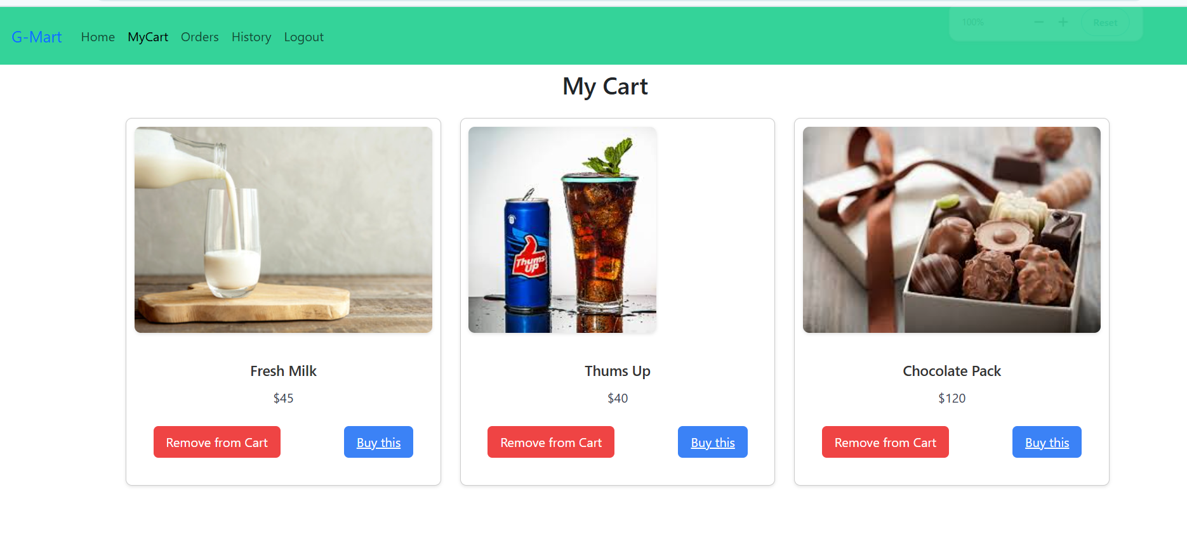

My Orders Page:-

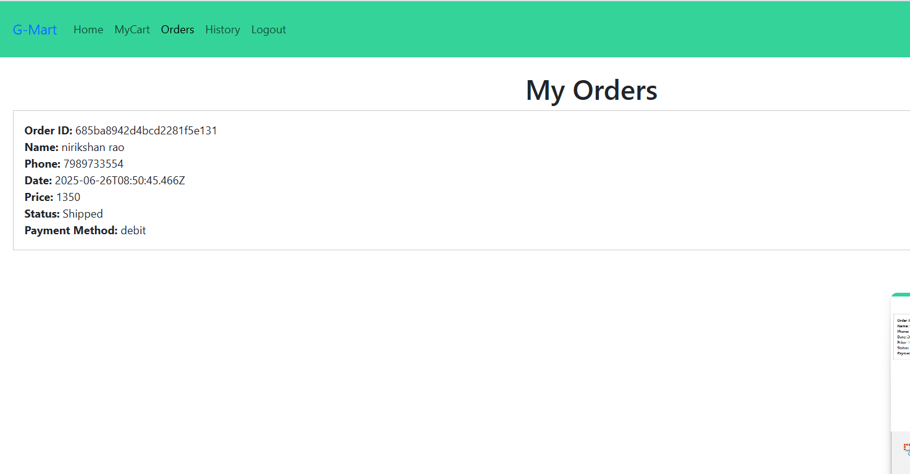

My History Page:-

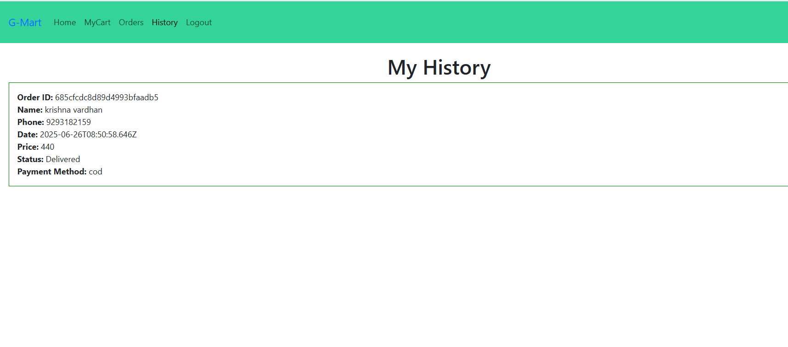

Place Order Page:

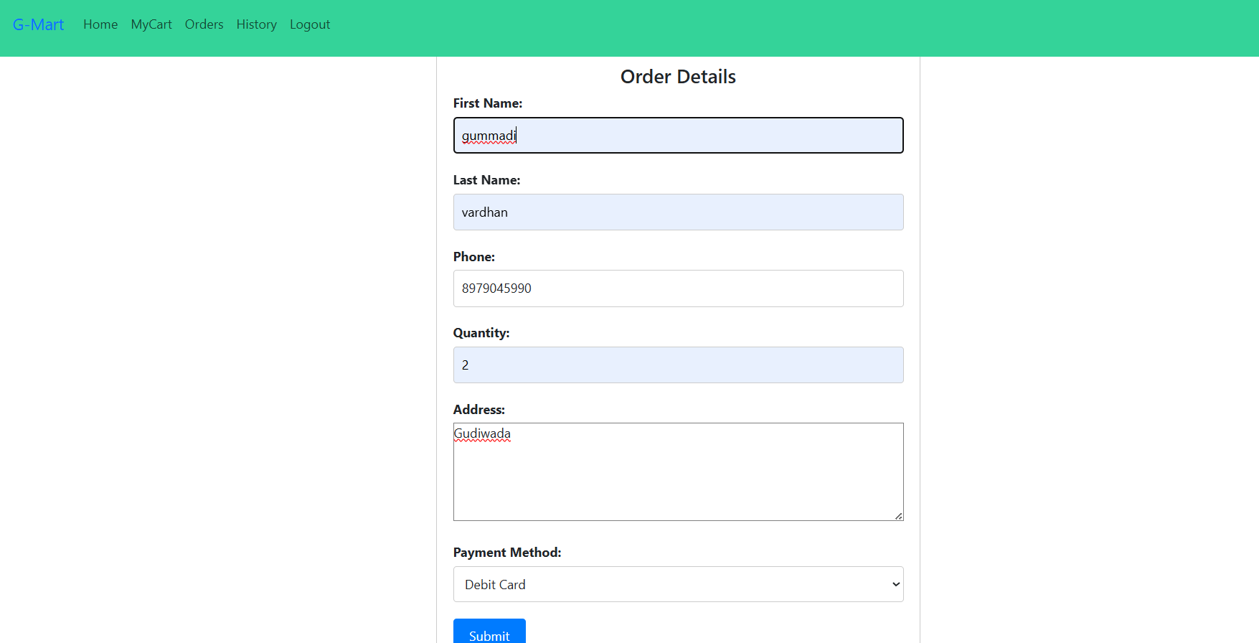

Admin Dashboard Page:

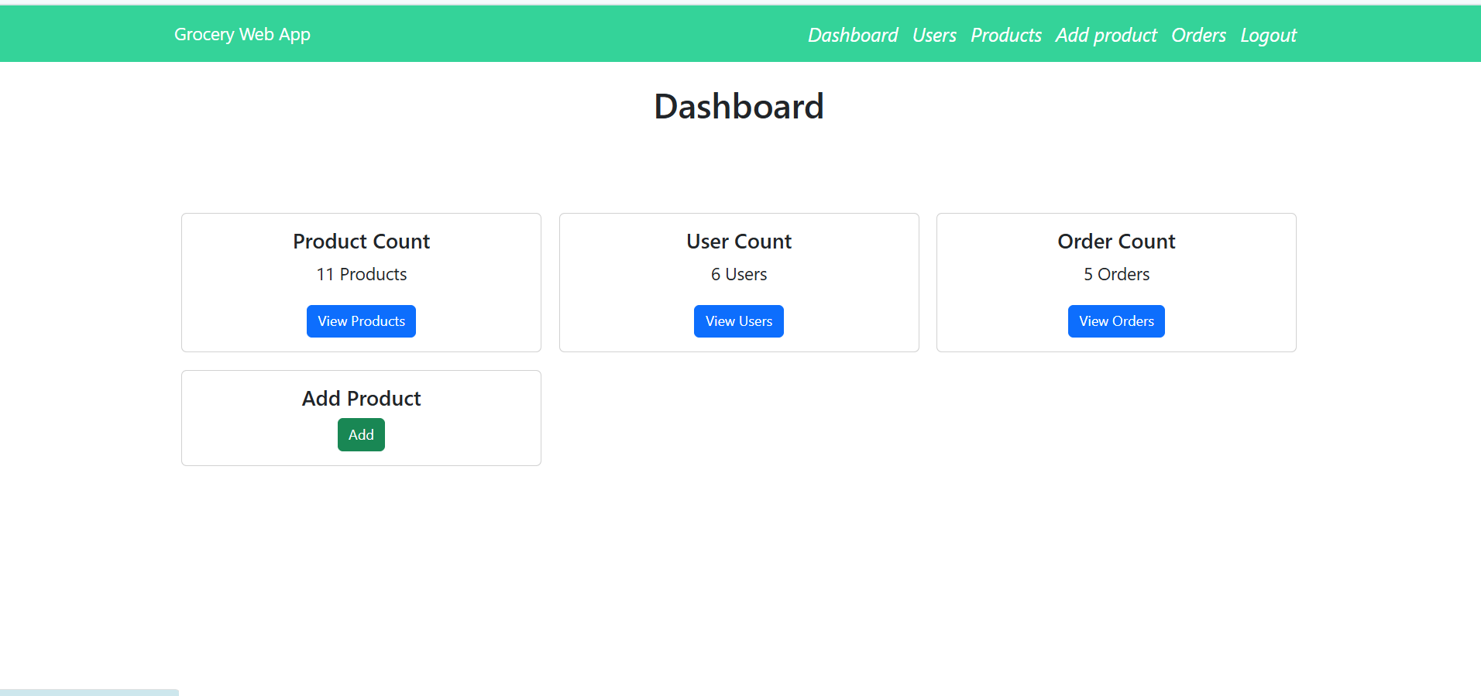

Users Page:

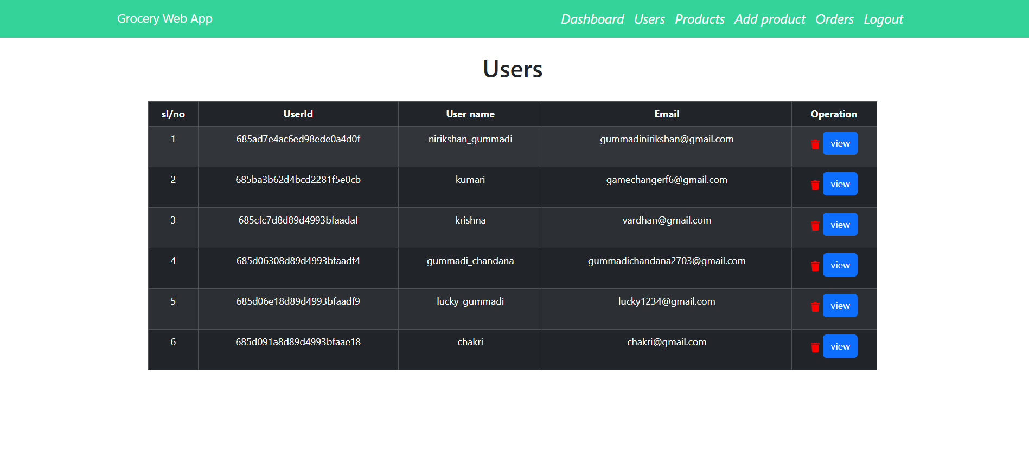

Add Product page:

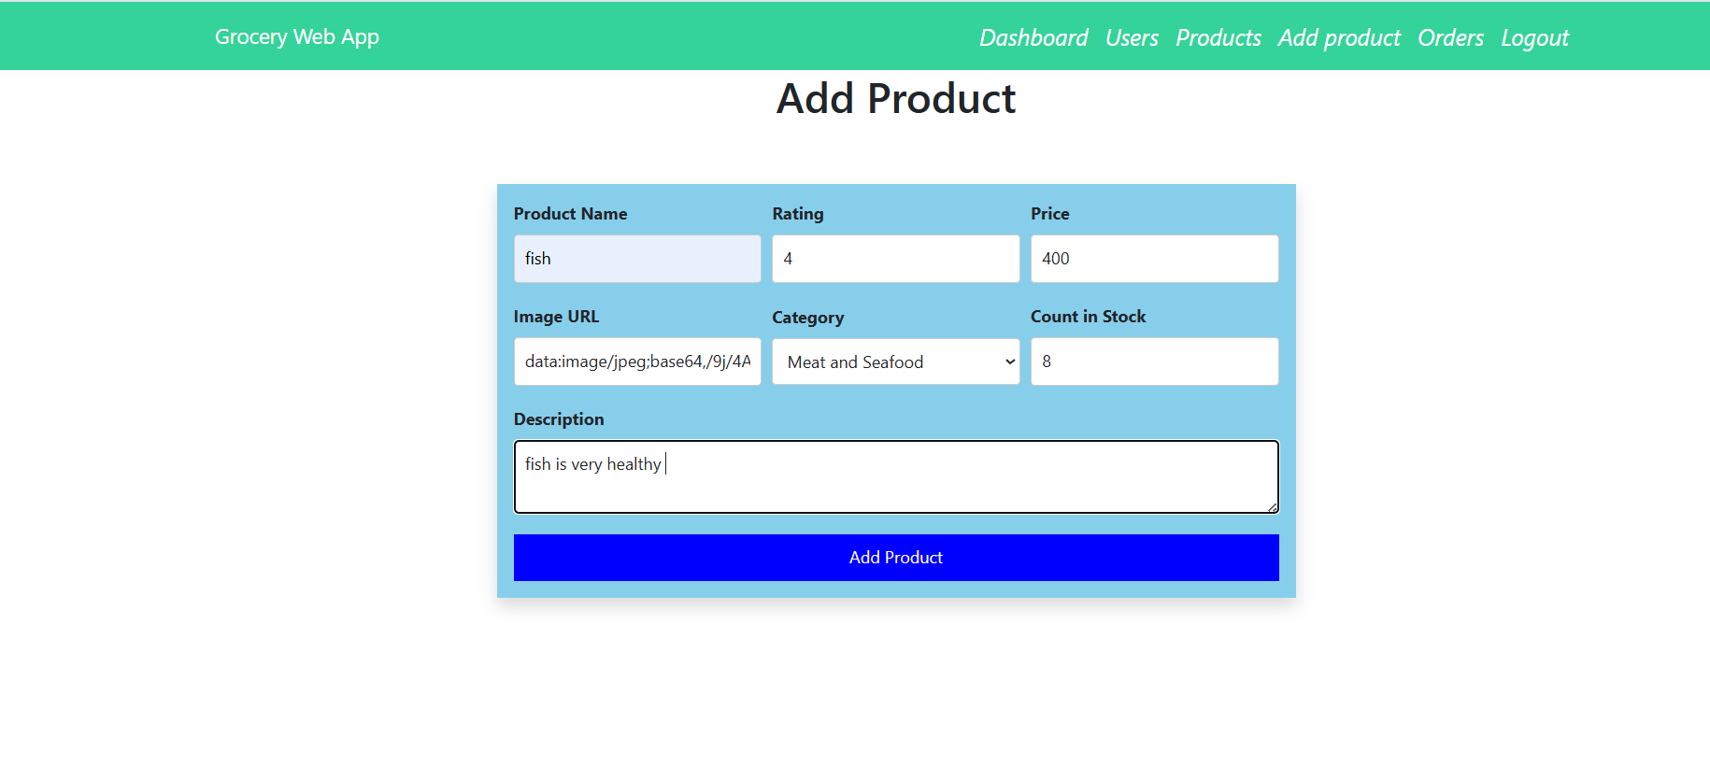

Admin Orders Page:-

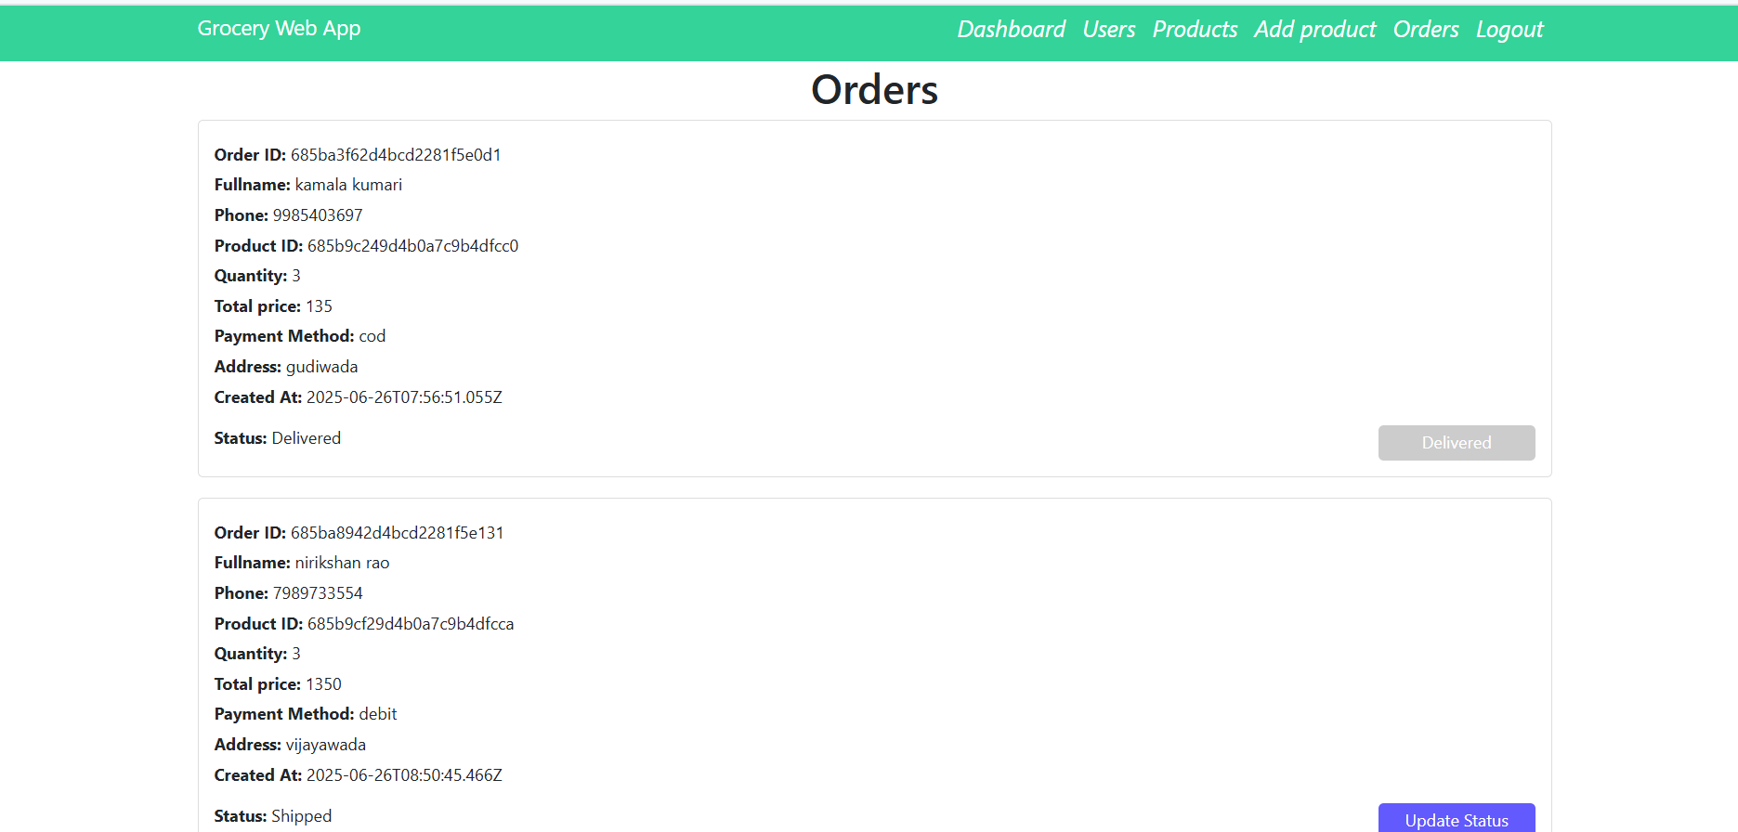

# Testing

The ShopSmart application is tested using **Postman** for API endpoint validation and **manual UI testing** to ensure smooth user experience across registration, login, cart, and checkout flows. Automated testing can be added using **Jest** and **Supertest** for backend coverage.

# Demo Link:

https://drive.google.com/drive/folders/12XDBQOhkmlnr7e3ncUEAUBrhfj5ACRnk?usp=sharing

# Known Issues

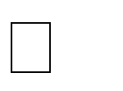❌ **No automated test coverage** – Testing is currently manual; missing unit and integration tests.

⚠️ **Limited error handling** – Some API responses lack detailed validation or error messages.

📦 **No pagination or filtering in product APIs** – May affect performance with large datasets.

🔐 **Token expiration handling not implemented** – JWT tokens do not auto- refresh, requiring manual re-login.

# Future Enhancements

**Add Refresh Tokens** – Implement secure token renewal to improve authentication flow.

**Mobile App Version** – Build a native mobile app using React Native or Flutter.

**Inventory Auto-Update** – Integrate real-time stock tracking for vendors.

**AI-Powered Suggestions** – Use machine learning to improve product recommendations.

**Chat Support System** – Enable live chat between customers and vendors.

**Subscription/Auto-Order Feature** – Allow users to set recurring grocery orders.

**Multi-language Support** – Expand user base by adding regional language options.

**Invoice & Billing Module** – Generate downloadable order invoices for customers.

**Analytics Dashboard** – Provide vendors/admins with real-time sales insights.